Here’s How To Build 100% Clean Renewable Energy In The US Before 2040
October 12th, 2016 by Guest Contributor
By Tom Solomon, 350 New Mexico
There really is a feasible way to build our way out of the climate crisis in time to avoid the worst effects of global warming. We do it by rapidly replacing all fossil fuel-based energy with renewable energy built with current technology, installed in a smart grid. We pay for it without damaging the economy and actually save money vs. our current reliance on fossil fuels. The ‘side benefits’ include cleaner air, cleaner water, less disease, more jobs and a livable climate.
The plan builds upon the great work done at www.thesolutionsproject.org led by Stanford University Professor Mark Jacobson. His work describes the end state of a 100% clean renewable energy future by 2050. What we add is a plan to actually build all that clean energy generating capacity, pay for the $6.3T cost over 22 years with the savings as we cease buying fossil fuels, and do it all in time to prevent the worst effects of the climate crisis.
We follow the mandate from the Dec 2015 COP21 Paris climate talks to keep total warming below 1.5°C by replacing all fossil fuels with clean renewable energy, with 50% by 2030 and 100% by 2050. This plan shows how to convert the US to 100% clean renewable energy (CRE). Similar plans could be created to convert the energy use for all other countries using the world-wide visions documented at the Solutions Project.

100% Clean, Renewable US Energy for All Purposes by 2050 (or Sooner)
Professor Jacobson’s May 2015 paper shows a 100% clean renewable energy (CRE) plan for the US with end-use consumption of 1,591GW of renewable power by 2050. This will be renewable power for all purposes (including heating, cooling, transportation & industry), not just electricity. With the conservative capacity factor assumptions from his study, averaging 22% for solar and 33% for wind, this 1,591GW of end-use power scales up to a ‘new-build’ requirement of 6,448 GW of new nameplate generation capacity. The components of this are:
3,966 GW PV-solar
2,421 GW Wind
61 GW of new Hydro+Geo+Wave+Tidal.
To build 100% of this 6,448GW by 2050 and 50% by 2030, the build-out for the 99% that is Wind and Solar would look something like this:
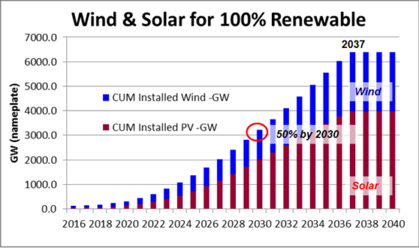
Fig. 1 Building 100% Clean renewable energy (CRE) for the US, with 50% by 2030.
Note in Fig. 1 that we reach 100% by 2037, not by 2050. This is an outcome of two factors:
1) The current factory capacity to build and install wind and solar is tiny vs this need. In 2015 the US installed 7.3GW of solar PV and 8.6 GW of Wind. If we kept installing at that rate we’d need 405 years to reach 100% or 6,448 GW. So we need massive new capacity.
2) The mandate to reach 50% by 2030 drives a wind and solar factory building boom of truly enormous scale. We have to build 488 gigafactories, most by 2029.
If we assume that each wind and solar factory is a ‘gigafactory’, ie it builds 1 GW/year of nameplate capacity, and the average solar panel is 300W and average wind turbine is 5MW, we’ll need to build on average 29 of these 1GW factories per year for almost two decades. By 2029 we’ll have all the 295 solar factories built and 113 of the required 193 wind factories. That’s what’s required to reach 50% by 2030. If we then keep building 20 more wind factories per year, all 193 are completed by 2034. These factories will have such huge combined output (488 GW/yr), that it only takes until 2037 to finish the build-out for 100%. See Figure 2.
SolarCity is building a solar panel gigafactory in Buffalo, NY, with production scheduled for 2017.
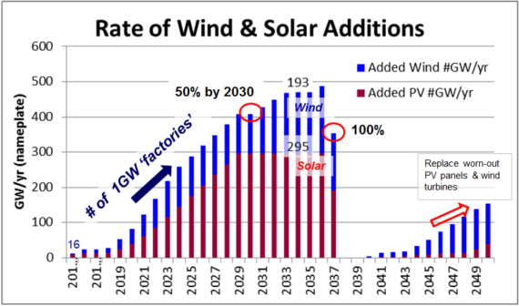
Fig. 2 Building the factories for 100% CRE, with 50% CRE by 2030.

What Will This Cost?
Since 99% of this new CRE build is solar and wind, that’s where we’ll focus, starting with solar.
- Solar – per NREL and the SEIA the installed cost of Solar has been dropping by 7% per year since 2009, as the US started installing at gigawatt scale and spending on solar rose to $20B/year. But to build 3,966GW of solar capacity through 2037, we’ll be installing vastly more, or an average of 200-300 GW per year and spending $158B per year. With that kind of market power I assume that this price reduction of 7% per year continues through the buildout. That takes installed costs from $2.15/Watt in 2015 to $0.50 per Watt by 2037. Pressure to compete on price for a share this huge business will drive that trend. Actual price reductions since 2013 have been faster than this 7% model, as the model forecasted 2015 at $2.51/W, not the $2.15 we actually reached. Using the 7% model and the back-end loaded buildout above, the total cost of installing 3,966 GW of Solar PV through 2037 comes to $3,524B in 2015 dollars or $158B/year. The average installed cost per Watt is $0.89. Installations of 300W panels must average 597M per year. For a vision of how costs could possibly get down to $60 per installed 300W panel, we could consider literally rolling them out like this.
- Wind – The IEA published a cost reduction study in May 2012, forecasting a 30% drop in installed wind costs by 2030, followed by <1%/year drops thereafter. I used these assumptions to scale the known 2013 installed cost of $1.63/W, down to $1.07/W by 2037. Thus the cost of installing 2,421GW of new Wind by 2037 ends up at $2,753B in 2015 dollars, averaging $125B per year at an average cost of $1.17W. Installations of 5MW turbines (both off-shore and on-shore) would average 21,373 per year from 2016-2037.
- Total — the cost of installing 99% of the required nameplate capacity for 100% CRE by 2037 is $3,524B+$2,753B = $6.3T. This is similar to the calculated total cost of the Iraq + Afghan wars.
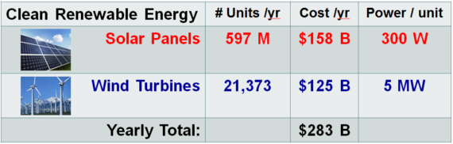
Fig. 3. For 22 years, (2016-2037) the US would install this much wind and solar capacity

How Can the Economy Save Money by Converting to 100% CRE?
Key to understanding how this $6.3T investment pays for itself is to realize that:
1) an energy system based on 100% renewables is fuel-free, and that
2) the US EIA reported that the US economy spent $875B/year on fossil fuels (including 1% on nuclear) in 2010. So for every additional 10% of renewable, fuel-free power that we install, the economy will save another $87.5B per year in lower fuel spending.
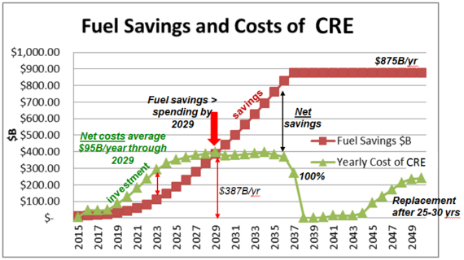
Fig 4. The investment costs and fuel savings as we convert to 100% CRE
Plotting the savings and costs as we convert, we see:
- Costs will peak around 2029 when total investment in wind and solar reaches $387B per year. But that year is also when yearly savings from lower spending on fossil fuels reaches that same level. Further spending will be roughly flat at about $387B/year through the full buildout in 2037, but yearly fuel savings keeps growing, until by 100% at 2037, the US economy is saving ALL of the former $875B we used to spend each year on fossil fuels (w/ 1% on nuclear ). Thus fuel savings alone will more than pay for the investment over time.
This is an economy-wide corollary to a homeowner installing solar panels on their roof, which pays off over time due to a lower (or zero) electric bill.
On top of fuel savings, Prof Jacobson estimates that the health care costs savings from lower air pollution would total $600B/year by 2050 (in 2013 $).
This is an investment with a great financial return. But it also explains why the oil, gas and coal industries are using their considerable political and economic power to prevent this future. That $875B per year is their revenue stream.
The net costs until the 2029 breakeven average $95B/year (net costs = investment-fuel savings).

What are Possible Ways to Fund the CRE Investment?
- Much of this investment will come from the private sector, as there is money to be made. A carbon tax on fossil fuels would spur CRE investment to be made sooner, and the need is urgent. A carbon tax could be revenue-neutral, as proposed by CCL.
- For direct government portion of CRE investments, a possible source of revenue could be a gas tax. Though a political anathema to some, a gas tax of $1 per gallon would raise $140B/yr, based upon the US 2015 gasoline consumption of 140B gallons.
That exceeds the $95B/year net CRE investment costs and is nearly half of the average $283B/year CRE investment required, before fuel savings.
With Jan-July 2016 gas prices averaging $2.20/gal, adding a $1/gal tax would still leave prices lower than their 2013-2014 levels of $3.50/gal. For fairness to lower income families, it could be paired with an increase in tax credits on earned income and child care.
- To put this spending in context, the US federal budget was $3.8T in 2015 with federal revenues totaling $3.2T (the rest was borrowing). The net CRE cost of $95B per year is less than the 2.7% of the budget that we spend on education ($102B).
- Of course an increase in income tax rates could be used. The NY Times reported that raising taxes on the top 1% to a 45% rate would bring in $276 billion.
- The cost of inaction on climate change could be $44T in losses by 2040: Citibank released a 2015 report showing that taking action now against the growing threat of climate change would save an astonishing $1.8 trillion by the year 2040. Conversely, the report says that if no action is taken, the global economy will lose as much as $44 trillion during that same time period.

What Else Must be Done?
The 100% CRE solution also requires electrified cars, trucks and trains.
RE air & sea transport may take technical breakthroughs to solve. Jacobson assumes compressed cryo-H2. Or it might be from algae-biofuels.
Building heating, cooling and hot water must be converted to renewables.
We must build a smart grid with some storage to handle intermittent renewable energy sources. This will require $24 B/yr for 20 years.
Invest in Geothermal, Wave & Hydro for the 1% of CRE that is not wind or solar.

Conclusion
The solutions to converting to a new, renewable energy economy are here now.
The barriers are political, not technical, and the need is urgent. The resistance comes from the economic sectors which will lose business (Oil, Gas & Coal and Utilities).
The US economy will easily handle the costs, which are comparable to the $6T of spending on the Iraq and Afghan wars.
Investments in clean renewable energy will ultimately be paid for by saving the $875B/year of wasted spending on fossil fuels.
The industrial challenge is mighty. But it’s less than the scale of the war-time conversion that the US completed from 1941-43. We did it before. We can do it again.

